Ryan Skidmore

Card Matching Game

**Purpose:** The purpose is to add a fun game that will challenge the brain and the memory to add growth.

**Audience**: The audience will be the people who want to be able to workout their brain to keep it active in a fun and entertaining way.

**Data Sources:**

**External API:**  Offscreen Canvas <https://developers.google.com/web/updates/2018/08/offscreen-canvas>

**Module List:**

Game()

Score()

Timing()

*Module names and function may vary*

**Wireframe**:

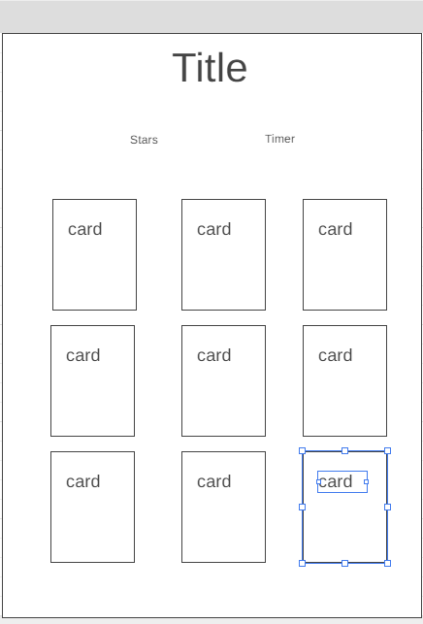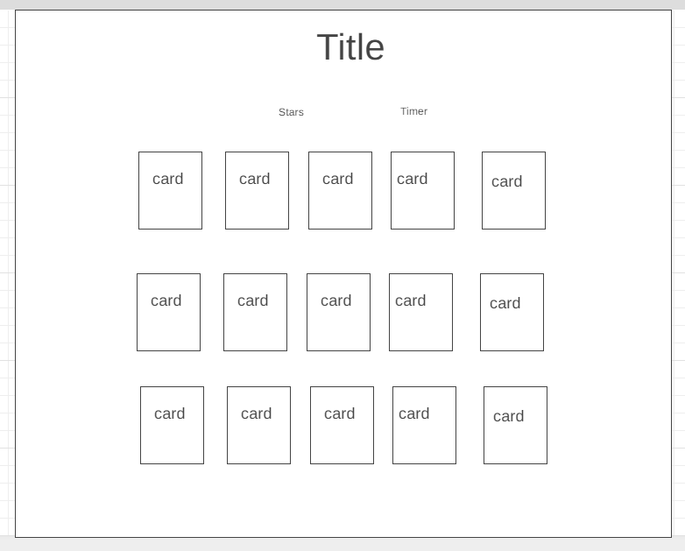

**Typography/Color Scheme:**

**Font -** Shadows Into Light

**Colors -**

**#243010 #87A330 #A1C349**